OSI 7-Layer Model

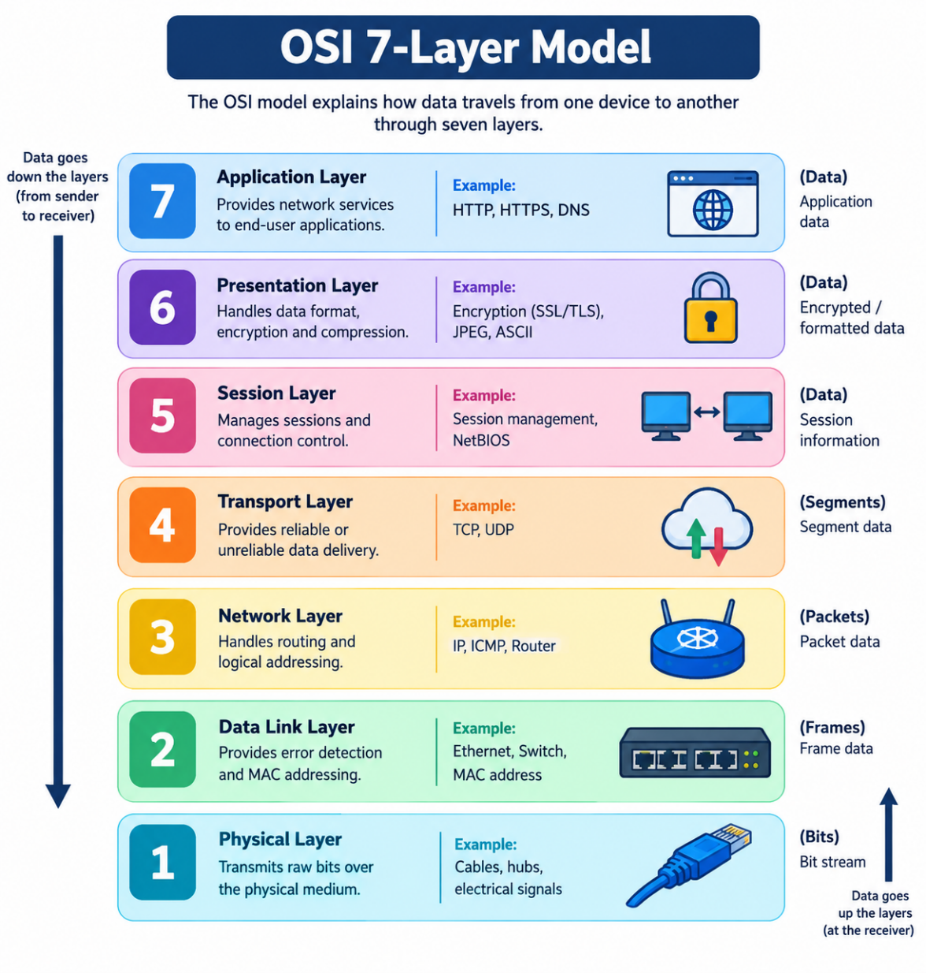

2. Match the Scenarios to the OSI Layers

a) Encrypting data before sending: Presentation (Layer 6)
b) Routing packets across networks: Network (Layer 3)
c) Converting data to electrical signals: Physical (Layer 1)
d) Opening a web page in your browser: Application (Layer 7)
e) Detecting and correcting errors in frames: Data Link (Layer 2)

3. How OSI Layers Work in Instagram

- Application (Layer 7): Instagram lets me send messages, upload photos, and view posts using application protocols such as HTTPS.
- Transport (Layer 4): TCP helps deliver data reliably when used by the connection.
- Network (Layer 3): IP addresses and routers help direct data from my phone across networks to Instagram's servers.
- Data Link (Layer 2): Wi-Fi or Ethernet carries data across the local network between devices.
- Physical (Layer 1): Radio signals or electrical signals carry the data through the physical medium.

4. Website Not Opening, but Ping Works
Possible OSI layers: Application (Layer 7) or Transport (Layer 4).

- Application Layer (Layer 7): The website service, browser, DNS resolution, or HTTPS configuration may have a problem.
- Transport Layer (Layer 4): The TCP connection to the website's required port, such as port 443 for HTTPS, may be blocked or unavailable.
Reason: A successful ping shows that ICMP packets can reach the IP address and receive a reply. It does not guarantee that the website's HTTP/HTTPS service is working.

